Easy-read Cervical Screening Invitation Letter Template
[GP Practice Letterhead]
[This letter includes text boxes to be completed before sending.]
Dear [insert patient’s name]
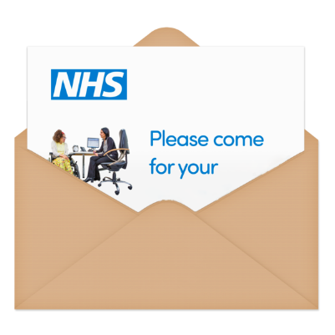 | This letter is to ask you to book a cervical screening test.  You might have heard it called the smear test.
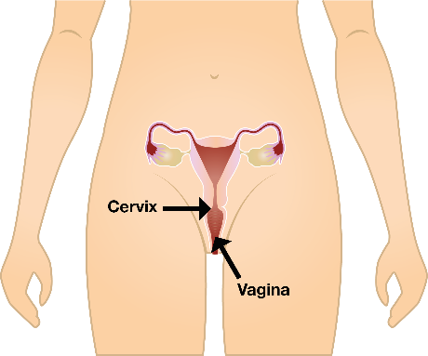 | Cervical screening is a test to help to prevent cancer of the cervix.  The cervix is inside your body at the top of your vagina.
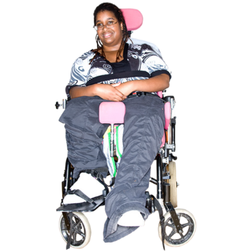 | Tests are offered to all women and people with a cervix aged 25 to 49 every 3 years and aged 50 to 64 every 5 years.
The test looks for a virus called HPV which can cause cervical cancer.

The test also looks for unhealthy cells.

You can catch the virus from any kind of sex or sexual touching from a man or woman.

You can have the test even if you have never had sex.

There is an easy read leaflet that tells you about the test. The leaflet can help you decide if you would like to do the test.
You can ask your doctors surgery for a copy of this leaflet or print it from this website:
https://www.gov.uk/government/publications/cervical-screening-easy-read-guide
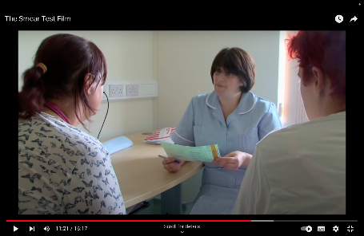 | You can watch a short film which explains what happens during the test.  The film is on this website:  https://www.jostrust.org.uk/information/videos/smear-test-learning-disabilities
You can talk to your family or carer about the test.
You can talk to a nurse at your doctors surgery.
Speak to your doctors surgery to make an appointment.

You can call us on the number at the top of this letter or come and see us to book your appointment.
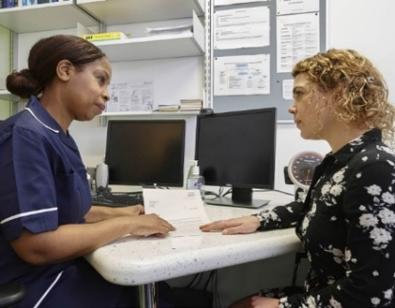 | You can ask to have the test with a female nurse.  You can ask for a longer appointment time.  You can take a friend, carer or relative with you.  You can ask the nurse questions before the test.
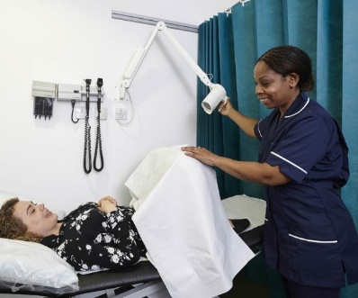 | The test will be in a private room.  The nurse will ask you to take your knickers off and lie on a bed.
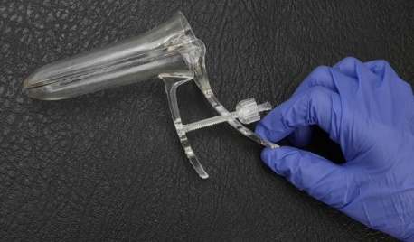 | The nurse will use a speculum to put in your vagina so they can take a sample of cells from your cervix.
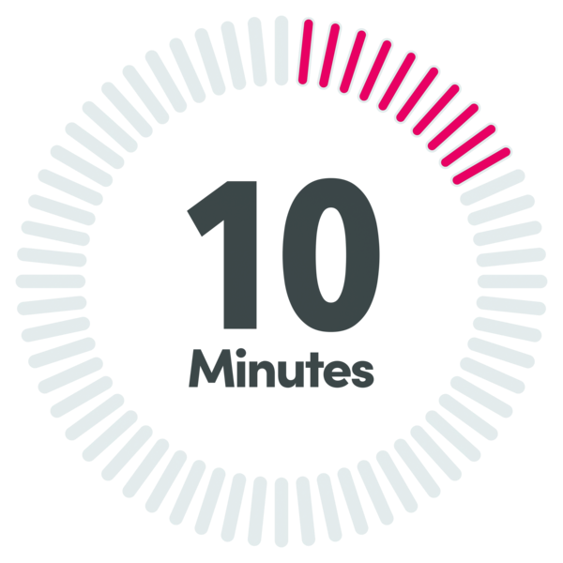 | The test only takes a minute or two.  The whole appointment usually lasts about 10 minutes.
 | You will get the result of your test in a letter or someone from the doctors surgery will phone you.

Yours sincerely
[Insert GP Practice details]

This letter is produced by: Barnet Mencap in collaboration with North Central London Cancer Alliance; Barnet Council; Camden Learning Disability Service (The Advocacy Project – Synergy Easy Read Group); Enfield Learning Disability Service (Easy Read Experts Group); and Islington Learning Disability Service (Power and Control Group).

