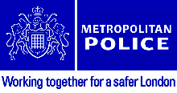 _________________________________________________________
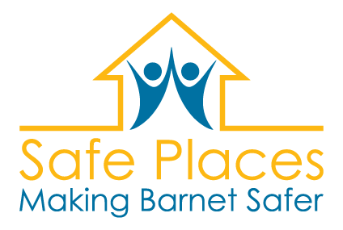
Survey on Safe Places in Barnet
This a Survey from Barnet Mencap. We are working with Barnet Council and the Metropolitan Police (Barnet Safer Transport Team) to make Barnet a Safe Place for all.
We would like to ask you some questions about your local community.
We want you to feel safe and happy when you visit public places such as shops, restaurants, cafes and community centres.
We would like you to share your opinions and views with us.

First, a little bit about you:
 | My name is_______________________
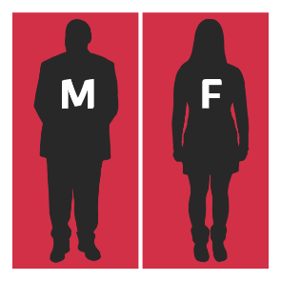 | I am a  Male Female
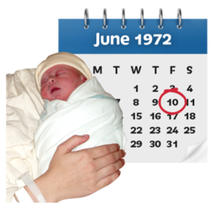 | I am _______________________ years old.
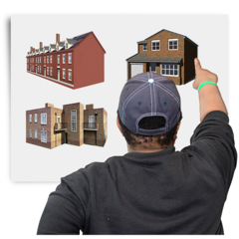 | Where do you live?  Supported Living Care home Nursing home Your own home  With family With carer With partner Somewhere else
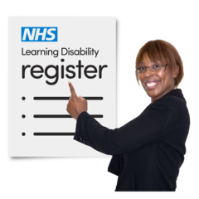 | Do you have a learning disability?
 | Do you have autism?
 | Do you have a physical disability or impairment?

We would like to know about your experiences in the community:
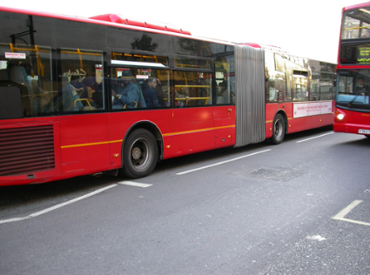 | Do you travel independently using public transport?
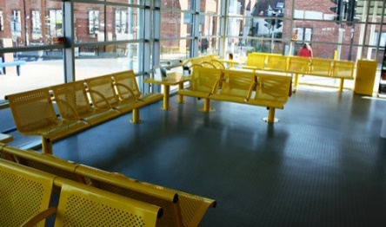 | Which Bus, Train or Tube Stations do you use?
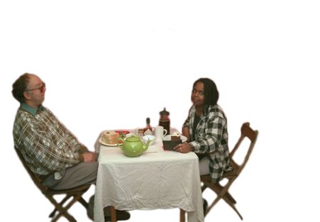 | Do you visit any cafes and restaurants?
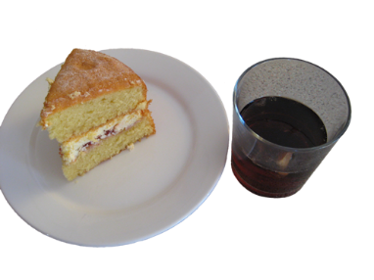 | Please tell us the names of any cafes where you like to have a cup of tea, drink or a snack:
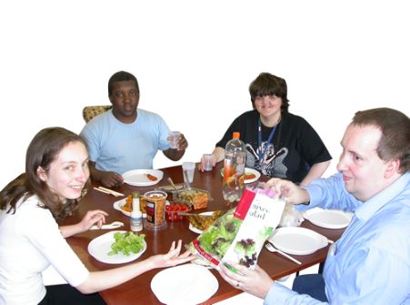 | Why are these cafes or restaurants your favourite places? Tick all that are correct.  Friendly Staff Helpful Staff Plenty of seats Not too crowed  Good prices Respectful to all customers Good food and drinks Something else
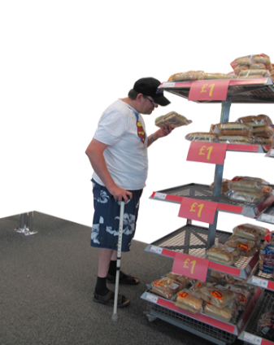 | Do you go shopping independently?
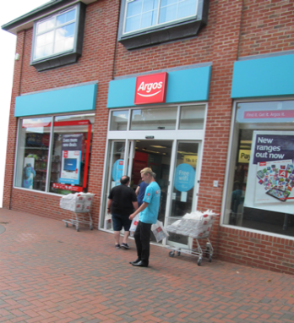 | Please tell us which shops you go to:
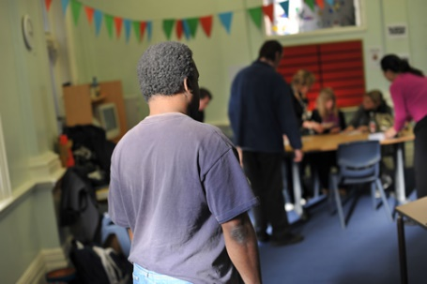 | Do you visit any community centres, support groups or clubs?
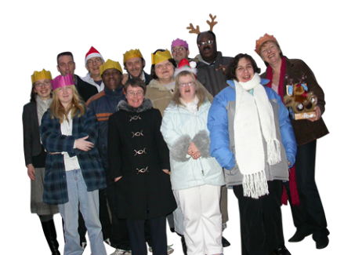 | Which community centres, support groups or clubs do you go to?
 | Do you ever feel anxious or frightened when you are out in the community?
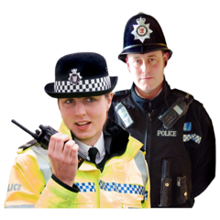 | If you were lost or felt anxious or frightened, would you like assistance to call someone?  Friend Partner Family Carer or support worker  Church, Synagogue, Mosque or other faith group Colleague, teacher or tutor Police Support group
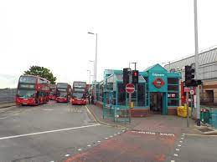 | Would you like to have independent travel training to help increase your confidence when you are out in the community?

Thank you for helping us with our survey. What you have told us will help us to try and change things to make it safer for you and others.

Please return completed Questionnaires to:
E-mail: projectsupport@barnetmencap.org.uk
Post: 35 Hendon Lane, London, N3 1RT
Or e-mail us at the above address to arrange collection.

_________________________________________________________

