JOB DESCRIPTION & PERSON SPECIFICATION
Job Title: Peer Engagement Worker for Learning Disabilities and Autism forensic services in North London
Hours: 2 days, 15 hours per week
Hourly Wage: £12.98 per hour
Location: Barnet Mencap (35 Hendon Lane, N3 1RT), and the North London Forensic Collaborative (4 Winsley Street, W1W 8HF)

Application deadline: 10th May 2024
Interview dates will be held at the Barnet Mencap office on Wednesday the 22nd of May

This form is available in easy read version.

If you’d like to learn more about the job, we are holding an introduction session at the Barnet Mencap office in 35 Hendon Lane, N3 1RT on April 23rd at 12-1pm. We can pay for your travel costs.

If you would like to join this session or need this form in another format, contact us on servicesupport@barnetmencap.org.uk or call us on 020 8349 3842 and ask to speak to Joby.

We are looking for two people to work as Peer Engagement Workers on our learning disability and autism wards in our secure forensic hospitals in North London

Purpose of the role:
Your role will be to speak to and listen to people with a Learning Disability or autism who are currently in a secure forensic ward.

Key tasks:
- You will listen to their experiences, views and opinions about the wards and how they feel about the care they get.
- You will share this information with the wider team
- The information you collect will be used to help us understand what is working well on the wards and help to make recommendations where things could be made better in the future.
- You will work closely with other members of the team, including people with lived experience as well as professionals.

You will work in Barnet Mencap and in 2 hospitals across North London:
- Chase Farm Hospital in North London: The Ridgeway Enfield EN2 8JL
- John Howard Centre in East London: 12 Kenworthy Road, Homerton E9 5TD

To apply, you must have:
- A learning disability, with or without autism.
- You have spent time being an inpatient in a secure forensic ward.
Skills needed for the role:
The role may be suitable if you:
- Want to make a difference for other people with learning disabilities and autistic people in these wards
- Enjoy talking to people and listening to their experiences
- Are able to travel independently, after initial support or training
- You will need to be able to build your confidence in your role to be able to work independently.
- You must be able to take instructions.
- You must be confident and comfortable speaking with others.
- You need to be able to tell someone if you have any concerns about you or others.
- Want to get some experience to work and to keep building more skills and confidence

Work Location:
You will work 2 days a week.
- One day you should be visiting inpatients in the wards at Chase Farm Hospital and John Howard Centre)
- On the second day, you will be working at Barnet Mencap (35 Hendon Lane, N3 1RT. See map below).

Sometimes, you may need to attend meetings at other locations.
Support for travel can be arranged and supported.

How to Apply:
You can apply in any way that suits you best. You need to tell us why you are the best person for the job and outline your skills and lived experience.
You can fill in the application form, write a letter or record a video explaining your suitability.

Reasonable Adjustments:
- You can ask for help from people you trust to make this application e.g. a member of your care team
- Attend an information session before applying at Barnet Mencap, 35 Hendon Lane, N3 1RT) on the 23rd April at 12pm.
- The interview process will be relaxed, allowing you to showcase your skills without pressure.
Contact us on 020 8349 3842 to discuss the best way to apply or to request additional support.
How to get to Barnet Mencap:
The closest tube station is Finchley Central. It is a 5 minute walk to Barnet Mencap offices. See the map below.
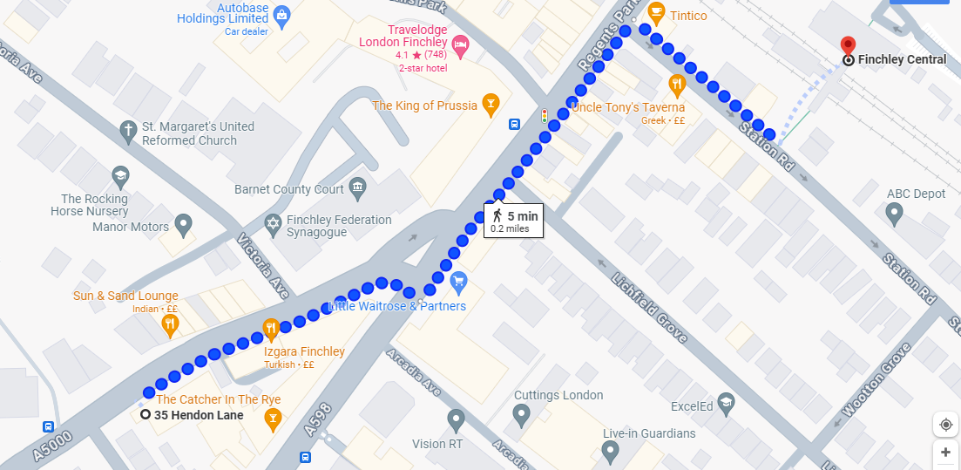
When you come out of Finchley Central turn left on Regents Park Rd.
Walk past Travelodge London Finchley.
When you reach Church End library, turn slightly right into Hendon Lane.
Walk for one minute and you will reach Barnet Mencap.
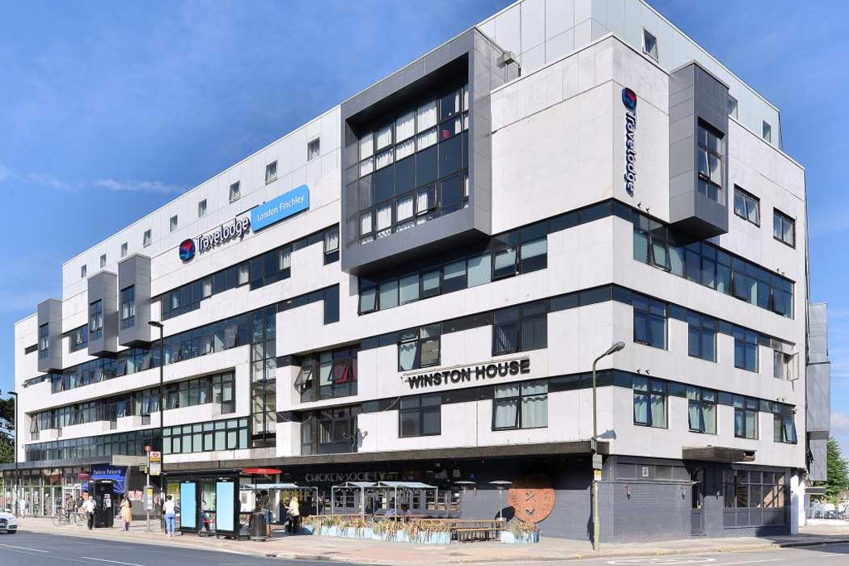
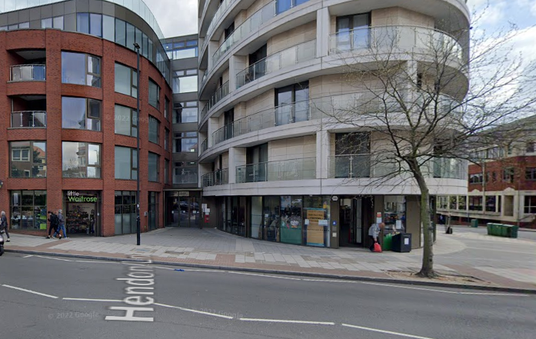
This is what Barnet Mencap office looks like: 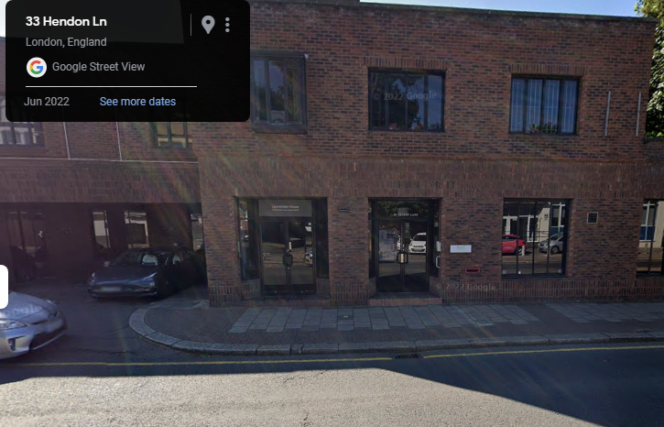
Barnet Mencap,
35 Hendon Lane,
N3 1RT
Job Description- Easy Read

Your role will be to speak to and listen to people with a Learning Disability or autism who are currently in a secure forensic ward. | 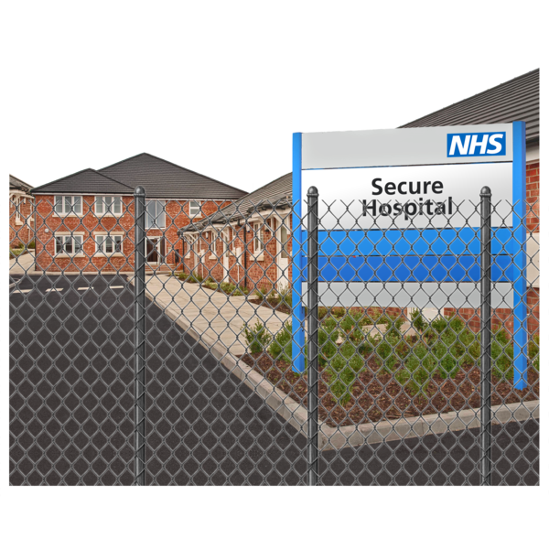
You will listen to their experiences, views and opinions about the wards. The information you collect will be used to understand what is working on the wards and help to make recommendations where things could be made better in the future.
You will work closely with other members of the team, including people with lived experience as well as professionals.

You will work in Barnet Mencap and in 2 hospitals across North London.

You must have a learning disability, with or without autism.

You want to make a difference for other people with learning disabilities and autistic people in these wards.
Enjoy talking to people and listening to their experiences.
You must be able to travel independently, after initial support or training | 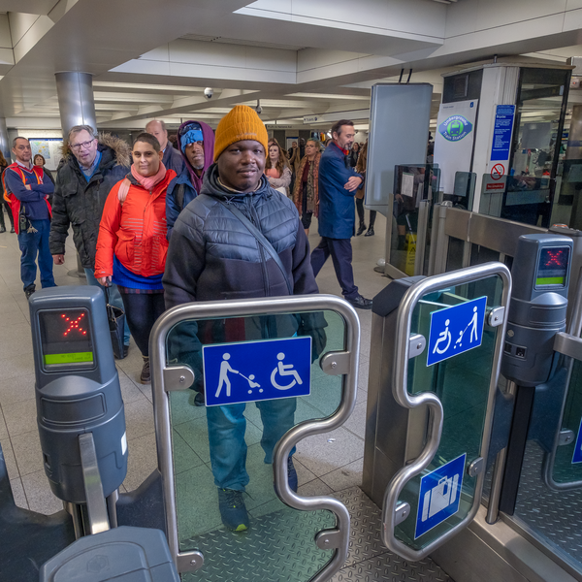
You must be able to build your confidence and work independently.
You must be confident and comfortable speaking with others.
You need to be able to tell someone if you have any concerns about you or others
To apply, you must have a learning disability, with or without autism.
You have spent time being an inpatient in a secure forensic ward.
You will work 2 days a week.  One day you should be visiting inpatients in the wards at Chase Farm Hospital and John Howard Centre. | 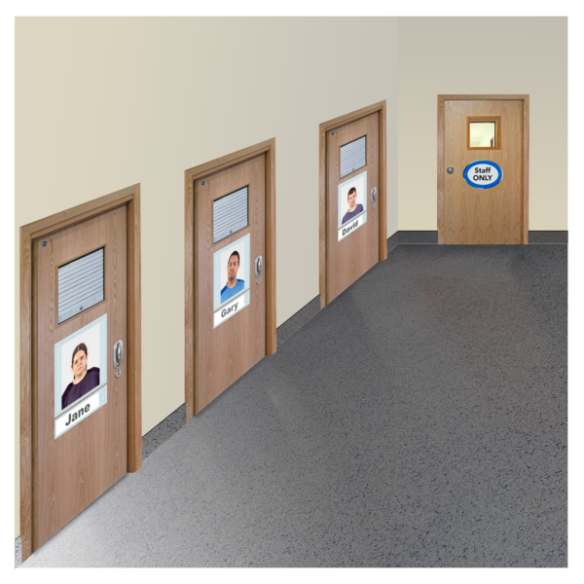
On the second day, you will be working at Barnet Mencap (N3 1RT).

You can apply in any way that suits you best. You need to tell us why you are the best person for the job and outline your skills and lived experience.

You can fill in the application form, write a letter or record a video explaining your suitability.

Reasonable Adjustments:
- You can ask for help from people you trust to make this application e.g. your user involvement leads
If you’d like to learn more about the job, we are holding an introduction session at the Barnet Mencap office in 35 Hendon Lane, N3 1RT on April 23rd at 12-1pm.
We can pay for your travel costs.

The interview process will be relaxed, allowing you to showcase your skills without pressure.

Contact us on 020 8349 3842 to discuss the best way to apply or to request additional support.

